**Project Design Phase-II**

**Technology Stack (Architecture & Stack)**

|  |  |
| --- | --- |
| Date | 30 June 2025 |
| Team ID | LTVIP2025TMID35420 |
| Project Name | Revolutionizing Liver Care : Predicting Liver Cirrhosis Using Advanced Machine Learning Techniques |
| Maximum Marks | 4 Marks |

**Technical Architecture Diagram**

The following diagram represents the system architecture of the proposed solution.

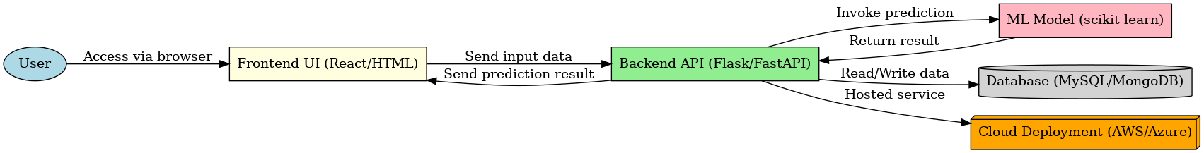

**Table-1 : Components & Technologies**

|  |  |  |  |
| --- | --- | --- | --- |
| **S.No** | **Component** | **Description** | **Technology** |
| 1 | Frontend | User Interface Development | React, HTML5 |
| 2 | Styling | Layout and Responsive Design | CSS, Tailwind |
| 3 | Backend | Handles ML logic and APIs | Python |
| 4 | API Framework | Handles API routing and responses | Flask / FastAPI |
| 5 | Machine Learning | Prediction engine | scikit-learn, pandas, numpy |
| 6 | Database | Stores patient and prediction data | MySQL / MongoDB |
| 7 | Deployment | Cloud hosting and scaling | Docker, AWS / Azure |

**Table-2: Application Characteristics**

|  |  |  |  |
| --- | --- | --- | --- |
| **S.No** | **Characteristics** | **Description** | **Technology** |
| 1 | Security | Protects user data and medical reports | Encryption, HTTPS |
| 2 | Performance | Fast response with ML predictions | Optimized ML models |
| 3 | Scalability | Can handle large number of users | Cloud-native architecture |
| 4 | Usability | User-friendly UI for patients and doctors | Minimalist design, responsive layout |
| 5 | Reliability | Accurate predictions and uptime | Proven ML algorithms, cloud hosting |